**PROJECT BASED LAB REPORT**

**On**

**Smart Washing Machine**

**Submitted in partial fulfilment of the**

**Requirements for the award of the Degree of**

**Bachelor of Technology**

**In**

**ELECTRONICS AND COMMUNICATION ENGINEERING**

**By**

**K.SUMA (160041036)**

**M.VENKAT SAI (160041041)**

**G.PAVAN KUMAR (160041045)**



**DEPARTMENT OF ELECTRONICS AND COMMUNICATION ENGINEERING**

**K L University**

Green Fields, Vaddeswaram, Guntur District-522 502

**2017-2018**

**K L University**

**DEPARTMENT OF ELECTRONICS AND COMMUNICATION ENGINEERING**



***CERTIFICATE***

This is to certify that this project based lab report entitled **“Smart washing machine”** is a bonafide work done by **K.Suma(160041036),M.Venkat sai (160041041),G.Pavan kumar(160041045)** in partial fulfilment of the requirements for the award of degree in **BACHELOR OF TECHNOLOGY** in **ELECTRONICS AND COMMUNICATION ENGINEERING**  during the Academic year 2016-2017.

**Faculty in Charge Head of the Department**

**K L University**

**DEPARTMENT OF ELECTRONICS AND COMMUNICATION ENGINEERING**



***DECLARATION***

We hereby declare that this project based lab report titled **“Smart Washing machine”** has been prepared by us in partial fulfilment of the requirements for the award of degree “**BACHELOR OF TECHNOLOGY in ELECTRONICS AND COMMUNICATION ENGNEERING**” during the Academic year 2016-2017. We also declare that this project based lab report is of our own efforts and it has not been submitted to any other university for the award of any degree.

K.SUMA (160041036)

M.VENKAT SAI (160041041)

G.PAVAN KUMAR (160041045)

**ACKNOWLEDGEMENT**

Our sincere thanks to **Yuvuraj Babu Dande** in the Lab for their outstanding support through out the project for the successful completion of the work.

We express our gratitude to **DR.V. SRIKANTH,** Head of the Department for Computer science and Engineering for providing us with adequate facilities, ways and means by which we are able to complete this project based Lab.

We would like to place on record the deep sense of gratitude to the honourable Vice Chancellor, K L University for providing the necessary facilities to carry the project based Lab.

Last, but not the least, we thank all Teaching and Non-Teaching Staff of our department and especially my classmates and my friends for their support in the completion of our project based Lab.

K.SUMA (160041036)

M.VENKAT SAI (160041041)

G.PAVAN KUMAR (160041045)

**ABSTRACT:**

Smart washing machine is a machine which is used to wash clothes smartly. In this project smart washing machine contains 6 options. Fully Automatic, Semi-Automatic, Washing, Soaking, Rinsing, Draining. While washing clothes if the water in the tank is low than 20% then the motor gets ON automatically and the tank fills to a particular safe level.

In Fully Automatic we have all the options starting from Soaking, Washing, Rinsing, and Draining. A timer is also given to show the indication of the time left for clothes to be washed. In Semi-Automatic we have only two steps washing and rinsing

To proceed into the project we use case structure to define all the types of modes. An enum control is created with all the six options of washing. For power on and start button we use Boolean button. For tank indication we use tank control and for pipes we use slide indicator. For indication of motor to be ON we use a Boolean indicator i.e LED.

For the washing machine I have used 4 different colour Booleans to represent different functions the washing is going through. Soaking process is represented by dark blue colour. Washing process is represented by blue colour. Rinsing process is shown by grey colour and finally drying process by beige colour or orange colour. When one led is glowing all other LED’s are not visible as I have used visible nodes for all the led’s.

Then to decorate my front panel I have used some pictures found in internet. And placed them as background of my front panel. To decorate my washing machine I have used the decoration option in front panel of the LABVIEW . then I gave colours of my choice to make it more attractive.

**TABLE OF CONTENTS:**

|  |  |  |
| --- | --- | --- |
| **S.No** | **Contents** | **Page NO** |
| **1** | Title and cover page | **1** |
| **2** | Certification | **2** |
| **3** | Acknowledgments | **4** |
| **4** | Abstract | **5** |
| **5** | List of figures | **7** |
| **6** | List of tables | **8** |
| **7** | List of symbols and abbreviations | **8** |
| **8** | Introduction | **10** |
| **9** | Technical description of project | **11** |
| **10** | Statistics | **16** |
| **11** | Experiments | **17** |
| **12** | Results | **22** |
| **13** | Conclusion & Future Scope | **25** |
| **14** | References | **26** |

**LIST OF FIGURES:**

* Fig 1 : capacity indication
* Fig 2 : comparison between top load and front load
* Fig 3 : Temperature setting in washing machine
* Fig 4 : Front load washing machine
* Fig 5 : options of latest washing machine
* Fig 6 : Top load washing machine
* Fig 7 : Trend in market
* Fig 8: block diagram of rinsing part
* Fig 9: block diagram of drying part
* Fig 10: block diagram of washing part
* Fig 11: block diagram of soaking part
* Fig 12: block diagram of semi-automatic part
* Fig 13: block diagram of fully automatic part-1
* Fig 14: block diagram of fully automatic part-2
* Fig 15: front panel of project
* Fig 16: options in smart washing machine
* Fig 17: result 1 fully automatic
* Fig 18: result 2 semi-automatic
* Fig 19: result 3 washing
* Fig 20: result 4 soaking
* Fig 21: result 5 drying
* Fig 22: result 6 rinsing
* Fig 23: result 7 motor on

**LIST OF SYMBOLS AND ABBREVIATIONS:**

**Wait ms:** Waits the specified number of milliseconds and returns the value of milliseconds timer



**Decrement:** subtracts one from the value



**increment:** adds one to the value



**Subtract :** computes the difference of the inputs



**AND :** Computes the logical AND of the inputs .Both inputs must be Boolean values ,numerical values or error clusters. if both inputs are TRUE the function returns TRUE otherwise it returns FALSE



**Greater?:** returns TRUE if x is greater than y otherwise this function returns false



**Select :** Returns the value wired to the t input or f input depending on the value of s ,if s is TRUE this function returns the value t if S is False the function returns the value of f



**Property node :**  Use the property note to get a set properties and methods on local or remote application instances, VI’S and objects

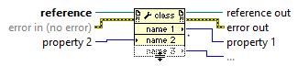

**Case structure :** Contains one or more sub diagrams or cases exactly one of which execute when the structure execute s. The value wired to the case selector determines the case to execute

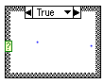

**For loop:** Executes its sub diagram n times Where n is the value of to the count (N) terminal ,the iteration I terminal provides the current loop iteration count which ranges from 0 to n-1

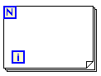

**Flat sequence:** Consist of one or more sub diagrams or frames that execute sequentially use the flag sequence structure to ensure that a sub diagram execute before or after another sub diagram. data flow for the flat sequence structure differs from data flow for any other structures. frame in flat sequence structure execute from left to right and when all data values wired to a frame are available

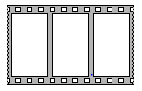

**INTRODUCTION:**

Clothes washer technology developed as a way to reduce the manual labour spent, providing an open basin or sealed container with paddles or fingers to automatically agitate the clothing. The earliest machines were hand-operated and constructed from wood, while later machines made of metal permitted a fire to burn below the washtub, keeping the water warm throughout the day's washing.

By the mid-1850s steam-driven commercial laundry machinery were on sale in the UK and US. Technological advances in machinery for commercial and institutional washers proceeded faster than domestic washer design for several decades, especially in the UK. In the United States there was more emphasis on developing machines for washing at home, though machines for commercial laundry services were widely used in the late 19th and early 20th centuries. The rotary washing machine was patented by Hamilton Smith in 1858. As electricity was not commonly available until at least 1930, some early washing machines were operated by a low-speed, single-cylinder [hit-and-miss](https://en.wikipedia.org/wiki/Hit-and-miss_engine) gasoline engine

After the items were washed and rinsed, water had to be removed by twisting. To help reduce this labor, the [wringer/mangle](https://en.wikipedia.org/wiki/Mangle_(machine)) machine was developed. As implied by the term "mangle," these early machines were quite dangerous, especially if powered and not hand-driven. A user's fingers, hand, arm, or hair could become entangled in the laundry being squeezed, resulting in horrific injuries; unwary bystanders, such as children, could also be caught and hurt. Safer mechanisms were developed over time, and the more hazardous designs were eventually outlawed.

The mangle used two rollers under spring tension to squeeze water out of clothing and household linen. Each laundry item would be fed through the wringer separately. The first wringers were hand-cranked, but were eventually included as a powered attachment above the washer tub. The wringer would be swung over the wash tub so that extracted wash water would fall back into the tub to be reused for the next load.

The modern process of water removal by spinning did not come into use until [electric motors](https://en.wikipedia.org/wiki/Electric_motor) were developed. Spinning requires a constant high-speed power source, and was originally done in a separate device known as an "extractor". A load of washed laundry would be transferred from the wash tub to the extractor basket, and the water spun out in a separate operation. These early extractors were often dangerous to use, since unevenly distributed loads would cause the machine to shake violently. Many efforts were made to counteract the shaking of unstable loads, such as mounting the spinning basket on a free-floating shock-absorbing frame to absorb minor imbalances, and a bump switch to detect severe movement and stop the machine so that the load could be manually redistributed.

### Automatic machines

Bendix Home Appliances, a subsidiary of [Avco](https://en.wikipedia.org/wiki/Avco" \o "Avco), introduced the first domestic automatic washing machine in 1937,having applied for a patent in the same year.Avco had licensed the name from [Bendix Corporation](https://en.wikipedia.org/wiki/Bendix_Corporation" \o "Bendix Corporation), an otherwise unrelated company. In appearance and mechanical detail, this first machine was not unlike the front loading automatic washers produced today. Although it included many of today's basic features, the machine lacked any drum suspension and therefore had to be anchored to the floor to prevent "walking". Because of the components required, the machine was also very expensive. For instance, the Bendix Home Laundry Service Manual (published November 1, 1946) shows that the drum speed change was facilitated by a 2-speed gearbox built to a heavy duty standard (not unlike a car automatic gearbox, albeit at a smaller size). The timer was also probably fairly costly, because miniature electric motors were expensive to produce.

Early automatic washing machines were usually connected to a water supply via temporary slip-on connectors to sink taps. Later, permanent connections to both the hot and cold water supplies became the norm, as dedicated laundry water hookups became common. Most modern front-loading European machines now only have a cold water connection (called "cold fill") and rely completely on internal electric heaters to raise the water temperature

:**How To Choose A Washing Machine?**

Let us first discuss about the most important factors that you have to consider while buying a washing machine. If it has been a while since you last bought a washing machine, then we highly recommend that you read this, as newer technologies and features are being incorporated in to home appliances every year.

### Capacity

Perhaps the first and foremost important factor that you have to consider while buying a washing machine is its **capacity.** The below image will help you make a decision about what capacity your washing machine ought to have.

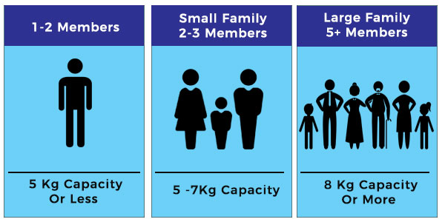

Fig 1 : capacity indiaction

### Front Load Or Top Load?

If you are on a tight budget, then a top load model would be a better choice. Most of the models are available in the range of Rs. 7-17k. The advantages of top load models are that you can **add clothes mid-way of a wash cycle,**ergonomically friendly (especially useful if you have trouble bending down and picking up things) and of course its budget friendly too.

On the downside, the top load models **consume lot of water, power,** doesn’t clean as well as a front load machine and has lesser features and wash programs compared to front load washing machines.

You might have heard that a major disadvantage of front load machines is that you cannot add clothes mid-way of a cycle. But manufacturers like Bosch, Samsung and IFB have now come up with advanced features that **allow adding clothes mid-way** of a wash cycle.

It has to be noted that front load washing machines need a **water pressure of 1 bar**, meaning the water supply tank should be placed at least 16.5 feet vertical height from the washing machine. This wouldn’t be a major concern for most Indian homes as the corporation and municipal water supply maintains 1 bar water pressure. **Front load machines** are comparatively expensive, but are **very efficient, consumes lesser water, power and cleans clothes much better.** They also have far more features, wash programs and are generally less noisy too.

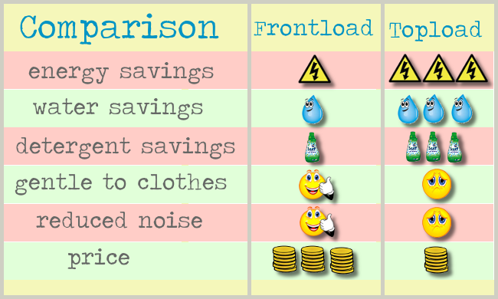

Fig 2 : comparison between top load and front load

So, to conclude, if you have a large family, or have kids who heavily soil clothes or if you are particular about cloth care and conserving electricity and water, then opt for a front load washing machine.If you are bachelor or a small family of 2-3 members and if your clothes don’t get heavily soiled, then a top load will be fairly good enough.

### Automatic or Semi-Automatic

If you are planning to buy top load machine, then you have the option of automatic and semi-automatic machines. Semi-automatic machines are **wider in size as it has separate washer and dryer**. After the wash cycle is completed, you will have to manually transfer the clothes to the dryer. Semi-automatic washing machines are pretty inexpensive with a price tag of Rs. 5 to 10k.

**Automatic washing machines** do not require you to transfer the clothes, but with certain models like Haier, you might have to add fabric softeners/ujala manually towards the end of the cycle.

### Temperature Setting

### Bosch has temperature setting from ****cold to up to 60 degree Celsius****, whereas temperature of water in LG and IFB washing machines can be cranked up to ****95 degree Celsius.**** This is useful if you have small babies at home or immunity compromised family members who need to have their clothes disinfected regularly.Most **top load machines do not have temperature control settings**, but rather have two inlet pipes for hot and cold water

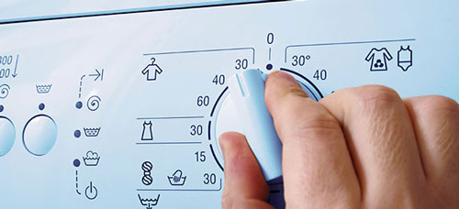

. Fig 3 : Temperature setting in washing machine

### Wash Programs

Each family has their own way of washing clothes. In our family, we always wash bath towels and bed sheets in ridiculously hot water. So, LG washing machine was our first option. But if you are a busy family who often forgets to put all clothes in a go, then Bosch or IFB might be a better choice for you. Families with working husband and wife will find machines with 24 hour time delay setting very useful.If you live in a place with heavy monsoon, then Monsoon settings in IFB and Bosch, which removes odour of damp clothes and dries clothes better would be something that you need. So, you might have to consider what are the features that you particularly need and the ones that you can compromise on, in order to choose an optimal solution within your budget.So, now, lets get on to the best washing machines in India.

## **Best Front Load Washing machine**

First, we take a look at some of the best front load washing machines we have shortlisted for you.

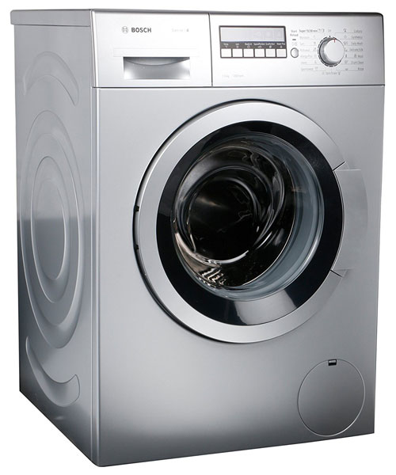

Fig 4 : Front load washing machine

The **WAK24268IN** model washing machine with 7 kg capacity**and max. RPM of 1200**, has advanced features specifically designed keeping Indian customers in mind. Before we get in to the features, lets discuss about its pros and cons. The major positive is that it has a variety of wash programs, flexibility in controlling temperature setting of each wash program and features like re-load function, anti-vibration design and monsoon program.

The areas where **WAK24268** lack is mainly that the temperature can be set from **cold to up to**60 degree Celsius, which is fairly good. But in LG and IFB, temperature can be cranked up to 95 degree Celsius.Also, the inlet pipe that comes with the machine is just 1 metre long. So, if at your home, the tap is not really close to the washing machine, you may have to spend extra for a longer inlet pipe. There are few complaints about delays in installation as well as rude behavior of technicians as well. So, be prepared! Now, let us get on to the features of the washing machine that really makes it a Wow! Machine.

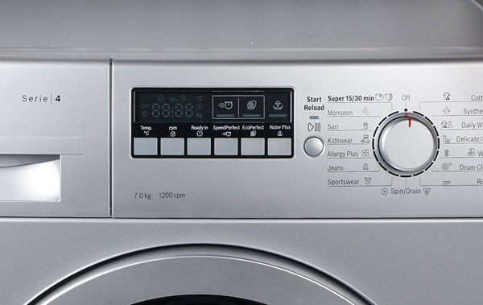

Fig 5 : options of latest washing machine

Bosch WAK2628 has a number of wash programs making it suitable for every need. In addition to regular programs like Wool, Silk, Daily Wash and Synthetics, it has **kids wear and super clean programs** for cleaning heavily soiled clothes without damaging the fabrics and Super 15/30 for quick wash within 15 and 30 minutes respectively. TheAllergy Plus **setting** helps to **keep the fabrics completely free off detergent residues**. Thanks to these features, Bosch Washing Machines are certified by **European Centre For Allergy Research Foundation**(ECARF).

If you live in an area with heavy monsoon, you will find the Monsoon program especially useful. With this setting, you can **remove the odour of damp clothes** and **reduce drying period by up to 10%.** Using the reload function, you can **add or remove clothing even after a wash cycle has begun**. This feature overcomes one of the major drawbacks of front-load washing machines.

Please do note that, as with every front load washing machine, the water pressure has to be at least 1 bar, roughly speaking, the overhead water tank has to be placed at a vertical distance of 16.5 ft. from the washing machine

**Other features include–**

* **Active Water,** which **optimizes water consumption** and cleans the wash drum with hot water to remove detergent residue and bacteria;
* **Anti-vibration Design** that reduces vibration and noise;
* **Speed Perfect**, which reduces wash time by up to 65%;
* **Time delay,** that helps you delay wash cycle from **1 to 24 hours**—a feature especially useful for home with working husband and wife;
* **VoltCheck,** which resumes wash cycle from where it has left in case of power failure;
* **WaterPlus,** which increases water flow to **completely rinse off detergents from clothes**—useful for homes that have soft water.

## **Best Fully Automatic Top Load Washing Machine**

Haier HWM58-020 is one of the bestselling washing machines in India**,** which is suitable for b**achelors and families with 2-3 members.** Featuring **rust-free plastic body, maximum RPM of 1000 cycles,** digital display of remaining time, this washing machine uses quadra flow system that create multi-directional water flow to clean clothes efficiently.

The machine has memory function which resumes from where it has left in case of power failure; delay timer from **30 minutes to 24 hours,** child lock and double level spin tub to reduce abrasion of fabrics. It also has **two lint filters,** thus helping improve the fabric quality after wash.

The wash programs include cotton, synthetics, mix, eco, prewash, quick wash and daily wash. All wash cycles can be completed in less than an hour.  
As the inlet pipe consist of a detachable hose and a pipe, you can remove the pipe and connect is as and when you need. So, you don’t have to keep it permanently attached like a front load washing machine.

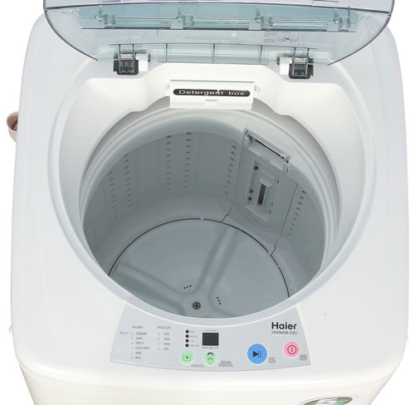

Fig 6 : Top load washing machine

**Trend of sales in market**

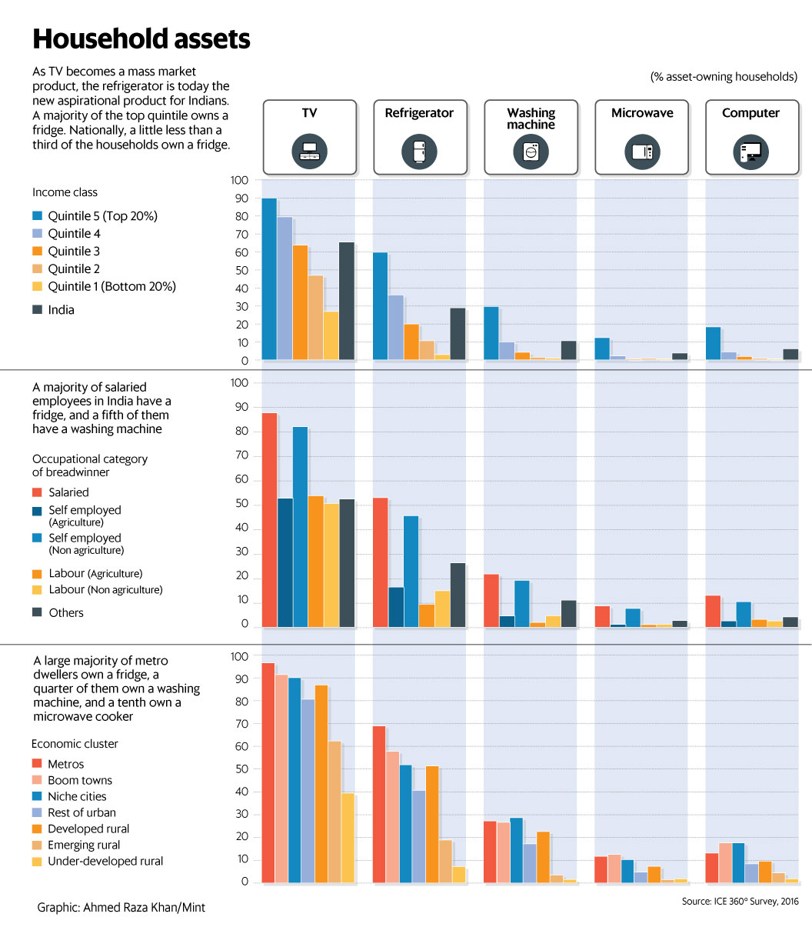

Fig 7 : Trend in market

**Experiment:**

**Create a VI that uses simple math to compute a number that people actually care about: their body Mass Index, or BMI. With obesity on the rise, the BMI is an increasingly useful number.**

**Step 1:** Create a new VI

**Step 2:** By right click in the block diagram select numeric controls of type enum and Boolean where ever required.

**Step 3:** create string indicator for status and numeric indicator for timer

**Step 4:** Decorate your front panel as required.

**Step 5:** Now take a case structure having true and false whose case selector terminal will be given to the power button.

**Step 6**: now create another case structure in the true case for the enum having functions of washing machine like washing rinsing soaking etc

**Step 7:** Now take a flat sequence within the case structure and create the functions which ever are needed . Define the functions of the washing methods

**Step 8**: within each and every case of the case structure given to enum give the countdown timer .

**Step 9**: now coming to tank and motor part , if the water in the tank is less than 20% then motor is given ON and the tank fills

**Step 10**: repeat this process for all the functions of washing

**BLOCK DIAGRAM OF LABVIEW:**

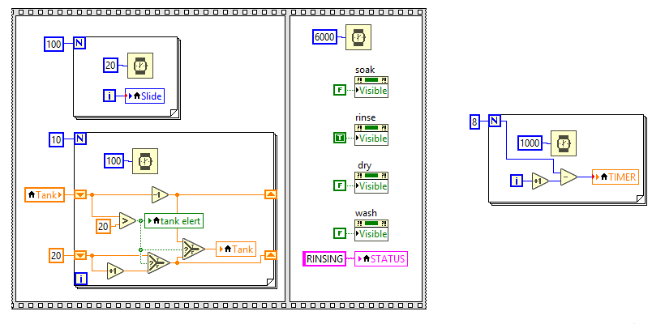

Fig 8: block diagram of rinsing part

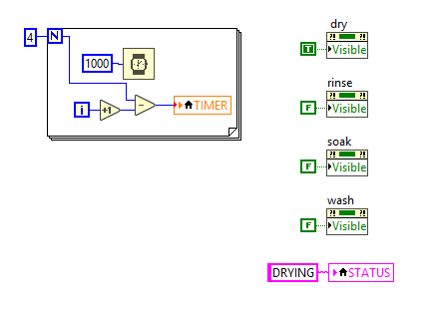

Fig 9: block diagram of drying part

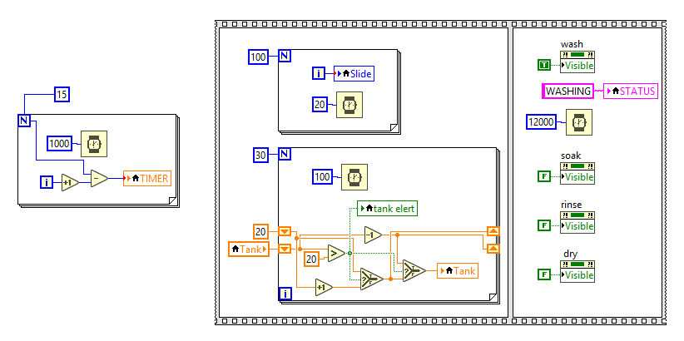

Fig 10: block diagram of washing part

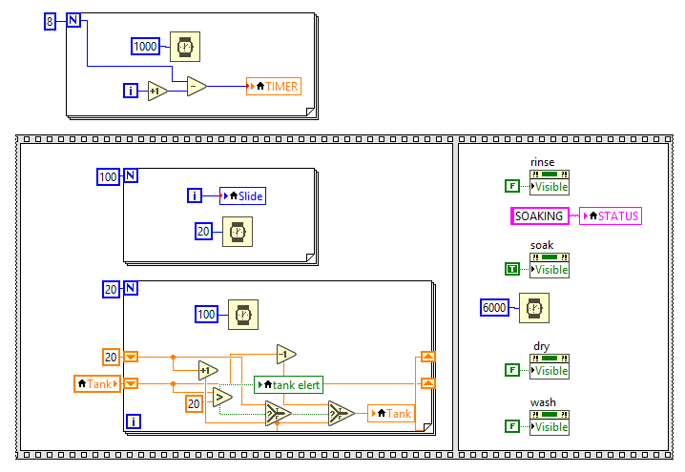

Fig 11: block diagram of soaking part

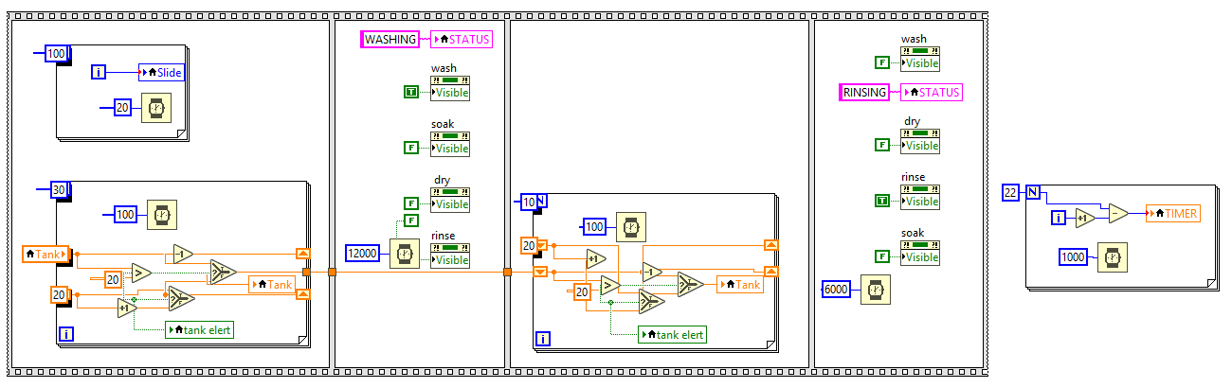

Fig 12: block diagram of semi automatic part

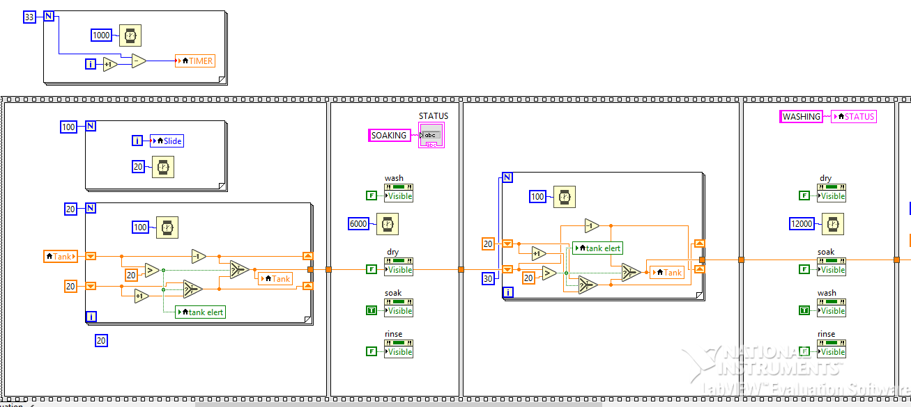

Fig 13: block diagram of fully automatic part-1

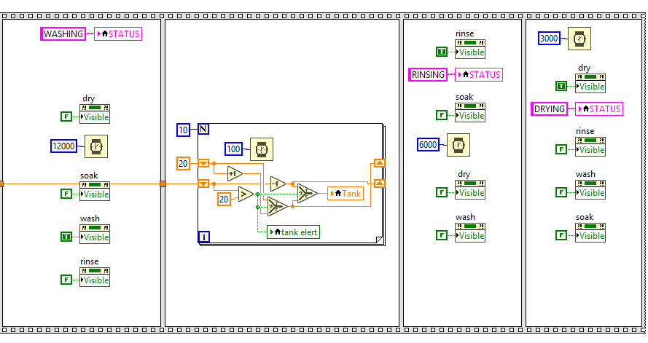

Fig 14: block diagram of fully automatic part-2

**FRONT PANEL OF LABVIEW:**

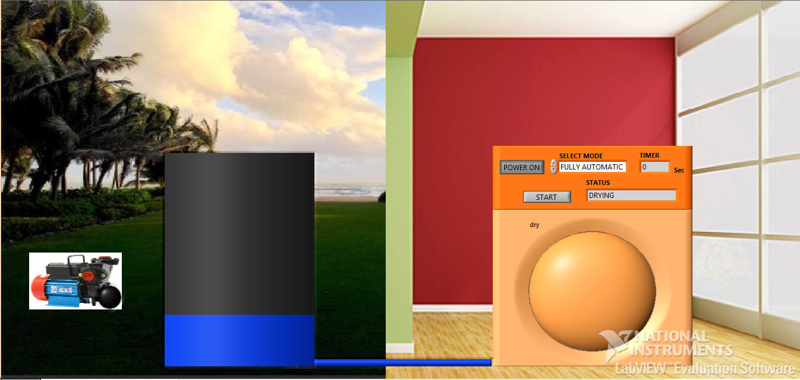

Fig 15: front panel of project

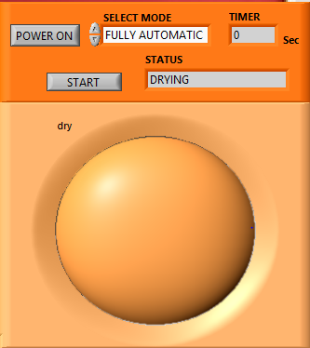

Fig 16: options in smart washing machine

**RESULTS**

**FULLY AUTOMATIC:**

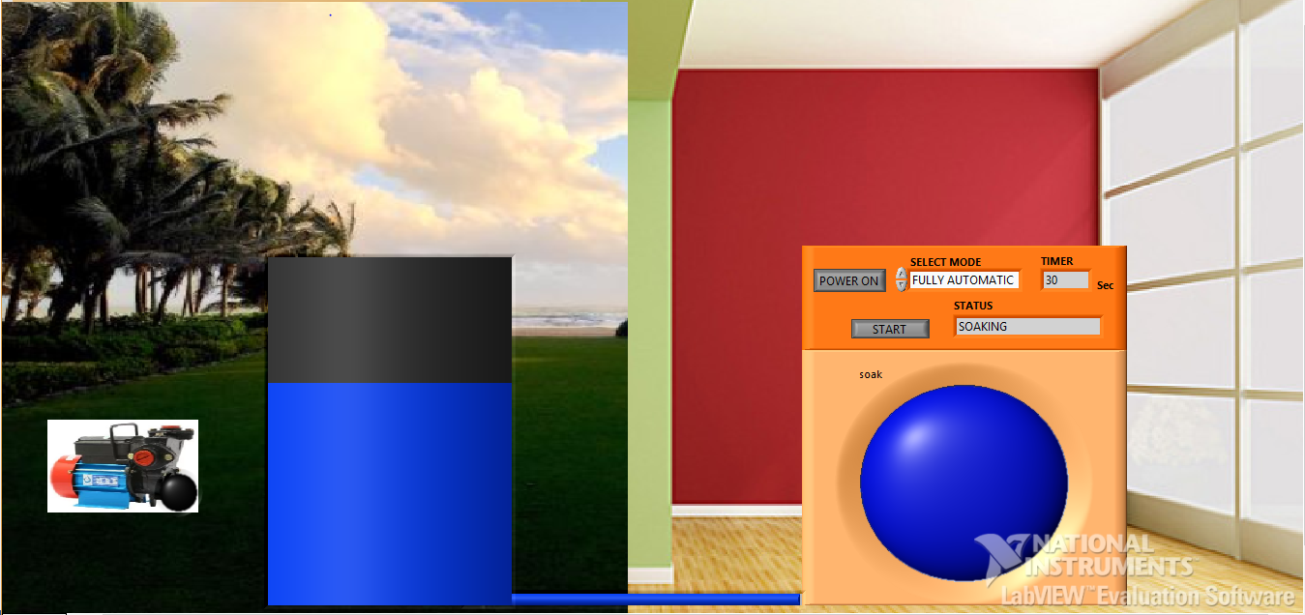

Fig 17: result 1 fully automatic

**SEMI AUTOMATIC:**

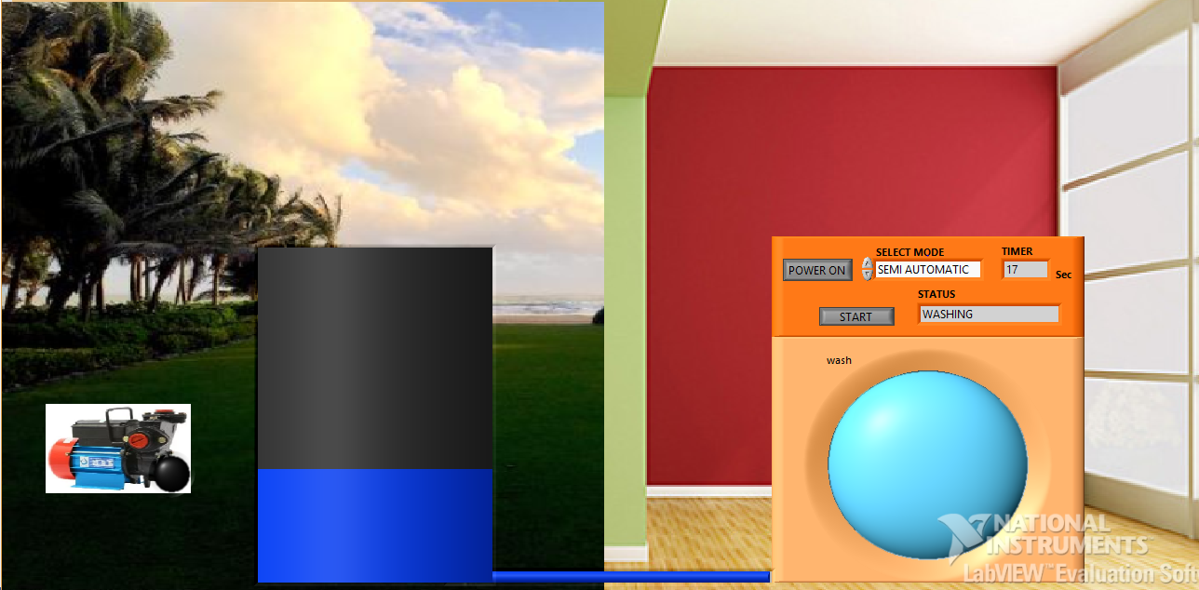

Fig 18: result 2 semi automatic

**WASHING:**

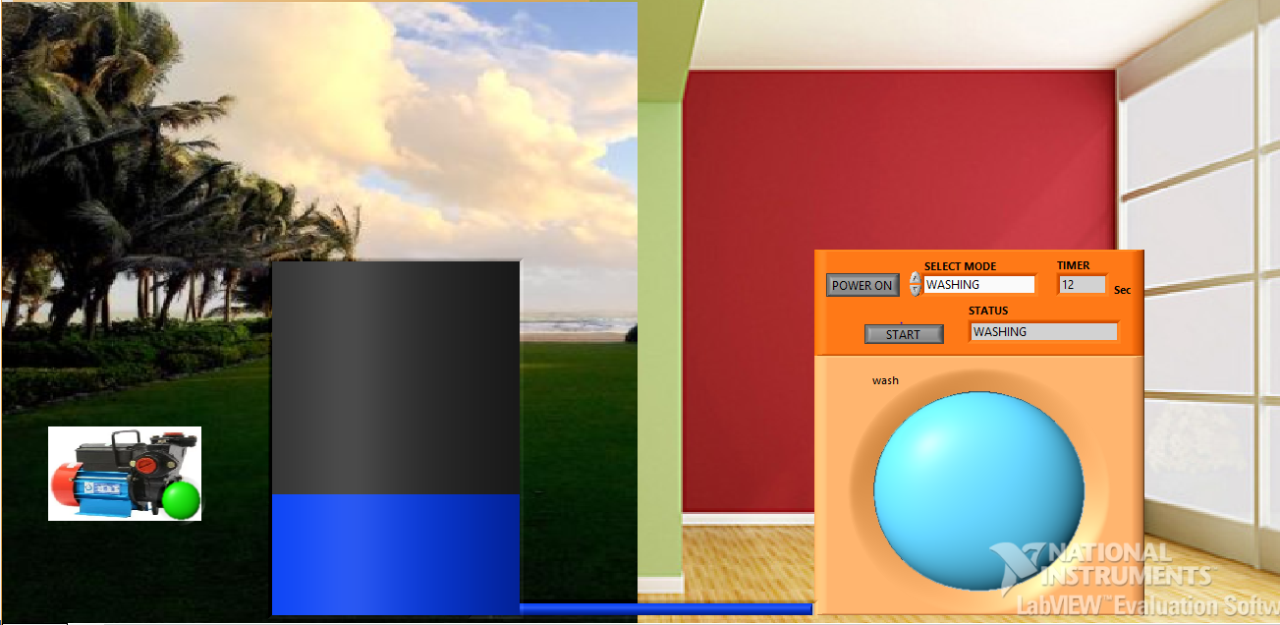

Fig 19: result 3 washing

**SOAKING:**

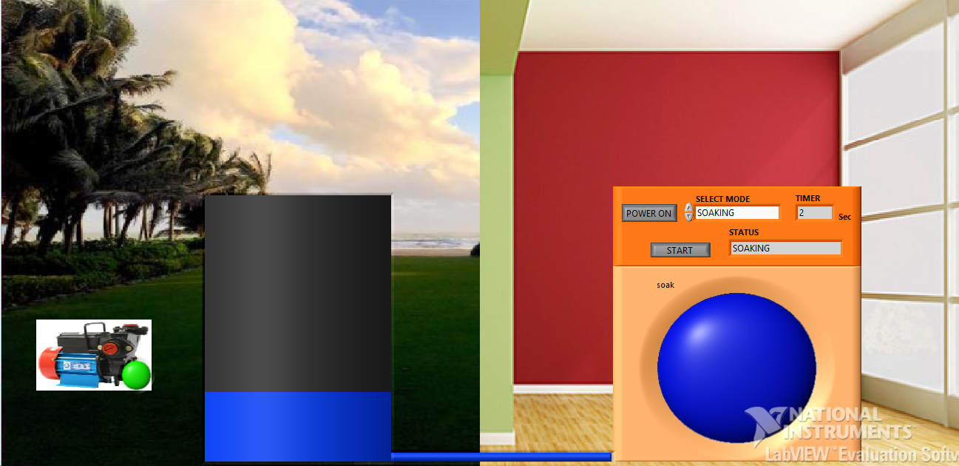

Fig 20: result 4 soaking

**DRYING:**

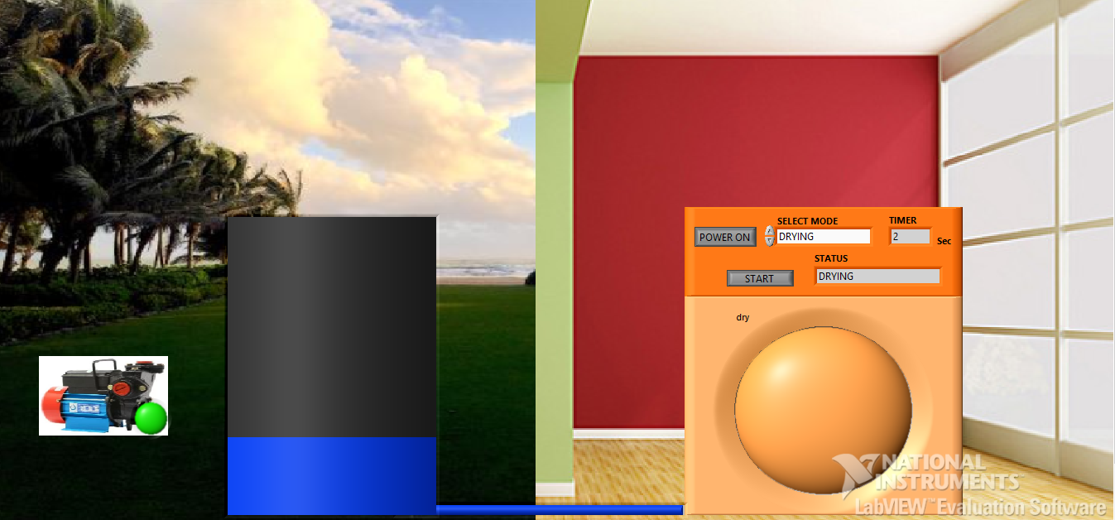

Fig 21: result 5 drying

**RINSING:**

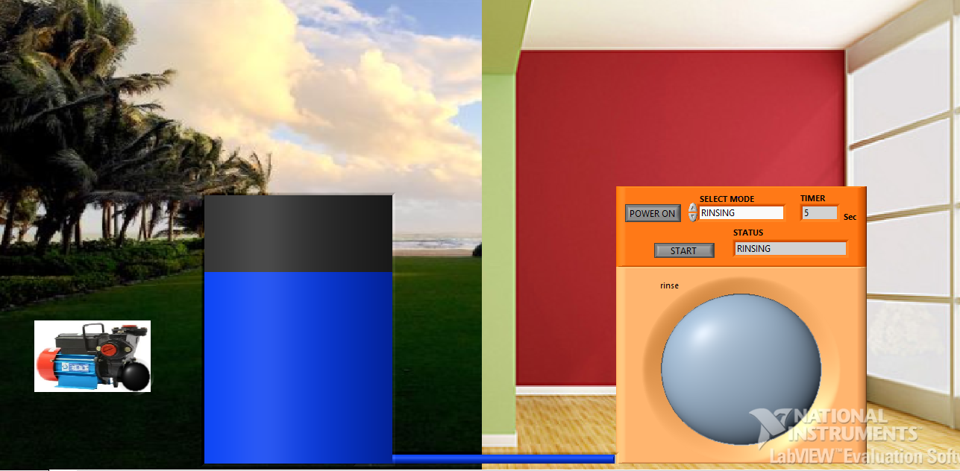

Fig 22: result 6 rinsing

**MOTOR ON :**

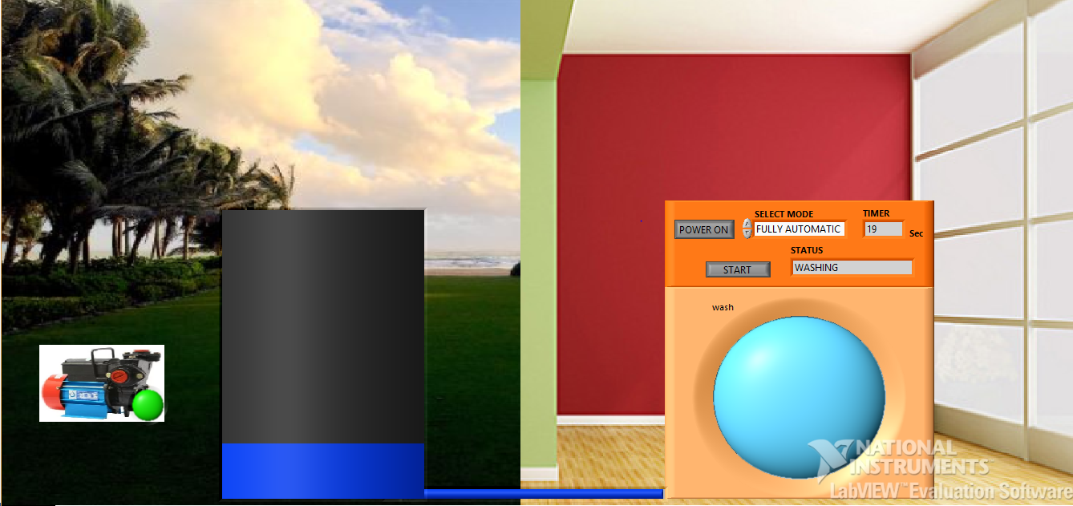

Fig 23: result 7 motor on

**CONCLUSIONS:**

Smart washing machines are user friendly and easy to be operated. If we use front loaded washing machine then the water consumption is also less and electricity consumption is also less. If you take top loaded washing machine then it consumes high power and more water is also consumed. Compared to front loaded top loaded washing machines are expensive. In front loading washing machines the durability of the motor is good. This project can further be developed in the regions like remote controlled or other comforts like automatic power control based on the voice recognition of the user

**FUTURE SCOPE:**

* In future washing machines may use beads instead of water
* Remote controlled washing machine may evolve
* Automatic detergent dosing
* Larger capacity washing machines

**REFERENCES:**

<https://en.wikipedia.org/wiki/Washing_machine>

<https://www.livemint.com/Specials/bhWpWqj3AFuETVdsC05fdM/In-India-washing-machines-top-computers-in-popularity.html>

<https://www.thehindubusinessline.com/economy/sales-of-washing-machines-languishing/article8765332.ece>

<https://pricebaba.com/washing-machine/pricelist/all-washing-machines-in-india>

<https://www.vijaysales.com/Appliances/Washing-Machines/6/235>

<https://www.kitchenarena.in/best-washing-machine/>